SOCIAL JUSTICE

Opening Prayer
Come, Holy Spirit, fill the hearts of your faithful, and kindle in us the fire of your love. Send forth your Spirit, and we shall be created, and You will renew the face of the earth. O God, who by the light of the Holy Spirit instructs the hearts of the faithful, grant that by that same Spirit we may be ever wise and rejoice in his consolations. We make our prayer in the name of Jesus Christ, our Lord, Amen.

Scripture Reading
Matthew 25:31-46 The Judgment of the Nations
James 2:14-24 Faith and Works

Introduction to Social Justice
- Personal Sin vs. Social Sin, example/s of social sin
- How to confront social sin, who is responsible for social sin?
- Pope Leo XIII and the Industrial Revolution
  - 1891 Rerum Nevarum (New Things)
  - Dealt with the major shifts in production brought about by the Industrial Revolution
  - Pope Benedict recently issued Charity in Truth (globalization among other New Things)
- Capitalism vs. Communism
- Society exists to serve individuals. Individuals do not exist to serve society.
- Social Ministry has two main aspects:
  - Social Service: giving aid directly to those in need
  - Social Action: correcting the root of the problem
  - Story of the bodies floating downstream to illustrate this
- Four Aspects of Social Justice
  - Solidarity: Living as though other people and living things matter.
  - Education: We are obligated to educate ourselves and others about social justice.
  - Community Organizing: Get involved in the community! Habitat, etc.
  - Advocacy: Giving a voice to those who have no voice: poor, sick, shut-in, unborn, dying, disadvantaged, immigrants, imprisoned, homeless, minorities, etc.
- Plan for the rest of the session
  - Tree Metaphor
  - Seven Key Themes to Catholic Social Teaching
  - Discuss Today’s Issues, could be small group

Closing Prayer
Almighty and eternal God, may your grace enkindle in all of us a love for the many unfortunate people whom poverty and misery reduce to a condition of life unworthy of human beings. Arouse in the hearts of those who call you Father a hunger and thirst for social justice and for fraternal charity in deeds and in truth. Grant, O Lord, peace to souls, peace to families, peace to our country and peace among nations. Amen

CATHOLIC SOCIAL TEACHING

TREE METAPHOR

Paraphrased summary to be read as the students look at the image of the tree.
God is the sower (planter) of our tree, and God’s Word is the seed, with God’s Word being the seed.
The roots are the bible, which nourishes and anchors the tree
The trunk is formed from the Church’s teachings on social justice – the letters from the popes and bishops. Our tree is alive and growing and as new teachings are issued, the trunk expands (grows rings).
The limbs of our U.S. tree are the principles given by the US Catholic Bishops.
The leaves are the issues which confront our Catholic Social teaching.
New branches grow as new issues challenge us (100 years ago embryonic stem cell research was not yet an issue).
Like the branches and leaves, the issues are interconnected in that they all flow from the roots and trunk. They are all nourished by and sprout from the same source: God, who is the earth in which the scriptures are rooted.
Created by Bernadette Dunn, Diocese of Crookston, October 2

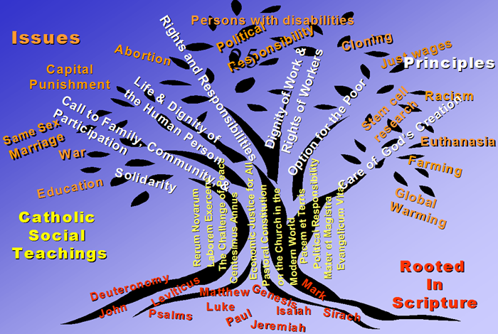

CATHOLIC SOCIAL TEACHING

SEVEN KEY THEMES
1. Life and Dignity of the Human Person
- Human life is sacred.
- The dignity of the person is the foundation of a moral society.
- In our society, human life is under direct attack from abortion, euthanasia, cloning, embryonic stem cell research, and more.
- Catholic teaching also calls on us to work to avoid war.
- The measure of every institution is whether it threatens or enhances the life and dignity of people.
2. Call to Family, Community, and Participation
- People are not only sacred but also social.
- How we organize our society—in economics and politics, in law and policy—directly affects human dignity
- Marriage and the family are the central social institutions that must be supported and strengthened, not undermined.
- People have a right and a duty to participate in society

3. Rights and Responsibilities
- Dignity can be protected and a healthy community achieved only if human rights are protected and responsibilities are met.
- Every person has a fundamental right to life and a right to those things required for human decency.
- Corresponding to these rights are duties and responsibilities.

4. Option for the Poor and Vulnerable
- Basic moral test: how our most vulnerable members are faring.
- We must put the needs of the poor and vulnerable first.

5. The Dignity of Work and the Rights of Workers
- The economy must serve people, not the other way around.
- Work is more than a way to make a living; it is a form of continuing participation in God’s creation.
- Basic rights of workers must be respected: right to productive work, fair wages, unions, and private property.

6. Solidarity
- We are one human family.
- Loving our neighbor has global dimensions.
- At the core of solidarity is the pursuit of justice and peace.
- If you want peace, work for justice.

7. Care for God’s Creation
- We show our respect for the Creator by our stewardship of creation.
- Care for the earth is not just an Earth Day slogan, it is a requirement of our faith.

SOCIAL JUSTICE ISSUES

USCCB.ORG
A society may be judged by how it treats its lowest citizens, typically the widows, orphans, and poor.

- Arms Control: The Harvest of Justice is Sown in Peace
- Campaign/Human Development: Domestic Poverty and choosing between hunger, housing, health care
- Catholic Social Ministry Gathering: human dignity of immigrants, international assistance
- Debt: Jubilee, lending & borrowing, countries paying debt vs. health care, education, water
- Domestic Issues: Family, Health Care, Housing, Labor, Social Security, Welfare
- Economic Justice: helping families in this recession, national budget cuts, stimulus should also help the poor
- Faithful Citizenship: form your conscience, voting guides
- Health: uninsured, Medicaid
- Housing: predatory mortgages, affordable housing, right to a decent home
- Immigration: JFI (Justice For Immigrants), should immigration be treated as a humanitarian or economic issue?
- International Issues: global poverty, environment, human rights, religious liberty, global trade, war and peace
- Labor Issues: unemployment, paid sick leave, unfair practices, minimum wage, migrant farmers
- Middle East: Iraq, Iran, Israel-Palestine, Lebanon
- Poverty: workers should not have to make hard choices between hunger, housing, and health care
- Social Security: will the U.S. properly consider the poor in future changes that will be required?
- Trafficking: FBI: human-trafficking operation: six recruiters lured 400 Thai laborers, took passports, forced to work.
- Welfare: what is the Catholic Church’s view on welfare?

SOCIAL JUSTICE YESTERDAY & TODAY

New Things & Charity in Truth
In 1891, Pope Leo XIII issued what has become the Magna Carta of Catholic social teaching, New Things, in which he dealt with the major shifts in production and new growth in productivity brought about by the Industrial Revolution that had seemingly moved the world into a new age.
Pope Leo addressed what he called the “new things” of that time. European society was in many ways split into two ideological camps, one socialist, demanding governmental control and the other arguing that the entrepreneurs and those who owned the means of production should be free to develop markets with the most capable (often that meant ruthless) rising to the top. Neither seemed morally correct to the Pope.
The Holy Father insisted on the value and dignity of the worker as a human being endowed with rights and responsibilities. He commended unions as legitimate and he insisted on a family wage that corresponded to the needs of the worker and family. He opened the way to humanize the industrial revolution and to bring Catholic principles about the person in society to factories and farms, markets and economies of a changing world.
That encyclical provided moral, and even spiritual, guidance for many of the great social reforms of the last century, including advances in public health, the banking system, public education, living wages, unions, and income security through the creation of Social Security, unemployment insurance, and similar programs. Then, as today, the Church was concerned about the balance between capital and labor, between owners and workers. Sometimes new technologies disrupt that balance and put economic justice and the social contract up for re-negotiation.
Pope Benedict XVI confronts this same challenge directly and clearly in his most recent encyclical. More than 100 years of papal “social encyclicals” have given the Church a number of principles based on the Gospels and the lived experience of the Church. These principles and experience are now an integral part of Church teaching that have built on Pope Leo’s encyclical with both continuity and new insights. To all these Pope Benedict has added a new theological vision expressed by the very title of his letter: Charity in Truth.
One of the principal “new things” addressed by Pope Benedict is globalization. Like Pope Paul VI before him, Pope Benedict uses the centrality of integral human development as one of the basic criteria to address the challenges of an interdependent world. Here the economic realities of one nation or one society are constantly being influenced by some or all of the economies and cultures of the rest of the world.
As a Church with a long tradition of bringing the light of the Gospel to the concrete social, economic, political, and cultural questions of the day, Pope Benedict reminds us that we as a nation and people do not live in isolation, we influence and are influenced by all the nations. More than ever, the dignity of the worker is a foundation upon which we should measure much of what is good, and not so good, in the financial, industrial, and service sectors of our economy and our world.
Work is a good for every person. Productive work receives its intrinsic value from the worker who gives of him or herself in the workplace. People without work retain their innate dignity as a human person; they lack, however, one of the major avenues for self-expression and self-fulfillment. Work is that aspect of life that allows us to care for ourselves and those we love and to contribute to the wider society. Thus, through our work and productivity, we provide for ourselves and families and contribute to the good of society and the world.
Pope Benedict links three interrelated components of society in a way that offers a hint at a new way or renewed way to think about a better future. They are the market, the state, and civil society. Economic life undoubtedly requires contracts, in order to regulate relations of exchange between goods of equivalent value. But it also needs just laws and forms of redistribution governed by politics, and what it is more, it needs works based on the Christian understanding that the world and all of creation is a gift from God.
This is very roughly quoted/paraphrased from Labor Day 2010: A New “Social Contract” for Today’s “New Things” by Bishop William Murphy, September 6, 2010 available on USCCB.org

